**1584. Min Cost to Connect All Points: -**

Medium Accepted: 197.7K Submissions: 303.5K Acceptance Rate: 65.1%

You are given an array points representing integer coordinates of some points on a 2D-plane, where points[i] = [xi, yi].

The cost of connecting two points [xi, yi] and [xj, yj] is the **manhattan distance** between them: |xi - xj| + |yi - yj|, where |val| denotes the absolute value of val.

Return *the minimum cost to make all points connected.* All points are connected if there is **exactly one** simple path between any two points.

**Example 1:**

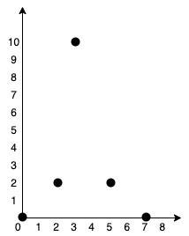

**Input:** points = [[0,0],[2,2],[3,10],[5,2],[7,0]]

**Output:** 20

**Explanation:**

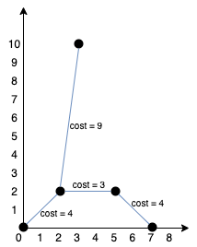

We can connect the points as shown above to get the minimum cost of 20.

Notice that there is a unique path between every pair of points.

**Example 2:**

**Input:** points = [[3,12],[-2,5],[-4,1]]

**Output:** 18

**Constraints:**

* 1 <= points.length <= 1000
* -106 <= xi, yi <= 106
* All pairs (xi, yi) are distinct.

**Code: -**

class Solution {

public:

    int minCostConnectPoints(vector<vector<int>>& point) {

        // Using Prim's Algorithm

        int v = point.size(), count = -1, ans = 0, dis, ver;

        if(v == 1)

          return 0;

        vector<bool> vis(v, false);

        //min heap of <edge_weight,vertex>

        priority_queue<pair<int,int>, vector<pair<int,int>>, greater<pair<int,int>>> pq;

        pq.push({0,0});

        while(count < v-1){

          dis = pq.top().first;

          ver = pq.top().second;

          pq.pop();

          if(!vis[ver]){

            vis[ver] = true;

            ans += dis;

            ++count;

            cout<<"("<<dis<<","<<ver<<")";

            // for all vertex from the current vertex

            for(int i = 0; i<v; ++i){

              if(!vis[i]){

                dis = abs(point[ver][0] - point[i][0]) + abs(point[ver][1] - point[i][1]);

                pq.push({dis, i});

              }

            }

          }

        }

        return ans;

    }

};